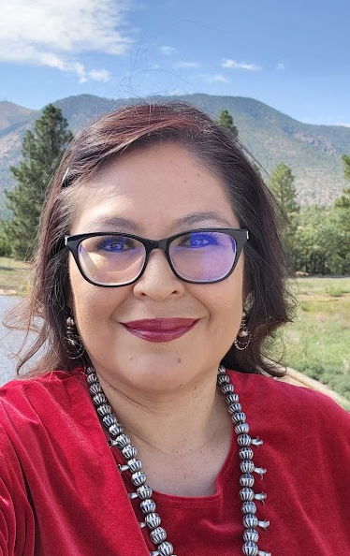
My name is Dr. Esther Cadman and I am a Din4 originally from Pinedale, New Mexico. I come from the clans of Dzi[t[‘ahnii (Mountain Cove People) born into Haltsoo7 (Meadow People Clan). My maternal grandfather is T0h baazhn7’1zh7 (Two Who Came to Water) and my paternal grandfather is Kinyaa’1anii (Towering House Clan). I have successfully achieved a Bachelor of Arts degree in Psychology with a minor in Family Studies from the University of New Mexico, an Educational Specialist degree in School Psychology from the New Mexico State University, and a PhD in School Psychology from Northern Arizona University. Currently, I am a practicing School Psychologist/Mental Health Coordinator with the Coconino County Education Service Agency serving schools located in the Western Navajo region that are within the boundaries of Coconino County. In addition to providing school psychology services to the schools, I also collaborate within a team of school-based mental health and teaching professionals to implement a Building Resilient Youth and Schools program that focuses on trauma-informed practical training with school staff and substance use prevention for youth. I also have 11 years of experience as a practicing school psychologist within New Mexico and Northern Arizona, serving mental health and special education needs for Native American children and youth from preK through 12th grade. I have worked with the Navajo Head Start providing consultation and coaching for teaching staff in head start classrooms across the Navajo Western Agency. I also have previous experience serving on professional boards such as a student representative for the Arizona’s Indian Children’s Program and as a co-president for the New Mexico State University School Psychology Graduate organization. This experience has helped me to gain valuable experience around discussions of organizational policy, regular attendance of quarterly board meetings, and annual board events.

As a Northern Regional Director, I will strive to utilize the duties within my role to promote opportunities for professional growth that pertain to the understanding and needs of local populations including children from various Native American tribes in the area. I will strive to promote professional education that encourages equity for all students and quality services by school psychology practitioners. My goal as a Northern Regional Director for AASP will also ensure efforts to communicate with school psychology members of the Northern region to keep them informed of the association’s professional activities, decisions, and knowledgeable support that impact the comprehensive role of school psychologists.

