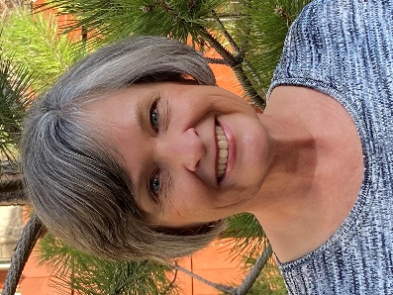
Kathy Bohan, EdD, NSCP I have been a school psychologist for almost 25 years and a trainer of school psychologists at Northern Arizona University for more than 20 years. Prior to completing my doctorate at NAU, I was a special education director and special education teacher for 15 years. I have served in urban, suburban, rural, and reservation schools throughout my career as an educator, certified school psychologist, and licensed psychologist. At NAU, I have held leadership roles as the Chair of the Department of Educational Psychology and the Associate Dean of the College of Education. Most recently, I was the NAU School Psychology Program Coordinator. I retired after the Spring 2021 semester. It is bittersweet to leave teaching and administration during the pandemic; however, I look forward to focused work with AASP and other volunteer endeavors.
With AASP, I have served as a Northern Regional Director for 12 years. I have co-chaired the Child and Family Advocacy Committee, and I recently served as the President-elect. I am also an active member of NASP, including attending and presenting at numerous NASP conventions and the Trainers of School Psychologists annual meetings.
As your AASP President, my goals are to advocate for our profession. We desperately need to address the shortage of school psychologists in our state. As an association, we must advocate for recruiting more individuals from racially, culturally, and linguistically diverse backgrounds into school psychology training programs. We will continue to address our legislative priorities including promoting mental health services for all Arizona children and youth. This includes promoting safe and effective learning environments and quality instruction across schools and districts. In all our work, we will integrate the lens of equity, diversity, and inclusion.
We look forward to offering high-quality professional development opportunities for our membership. We will return to an in-person annual conference November 4-5, 2021. However, we recognize that our virtual sessions have provided our members and other stakeholders with better access to professional development. We will continue to offer virtual trainings through the year, as well as explore other delivery formats. We want to do more than offer professional development. We want to advance the visibility and viability of our profession by offering relevant and advanced trainings to be best prepared to serve Arizona PK12 students.

