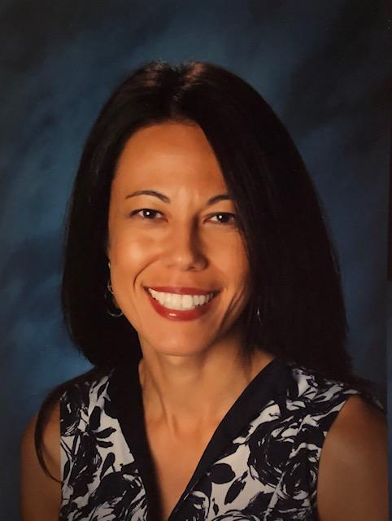
Stacy Anderson, PsyD, MC, NCC
Central Region Director

“Grown-ups never understand anything by themselves, and it is tiresome for children to be always and forever explaining things to them.” ― Antoine de Saint-Exupéry

The AASP board members have a history of making significant contributions in our field. I am honored to have the privilege to serve this organization for the continued advancement of our profession. In fulfilling this position, I understand that my primary responsibilities include being a voting member of the board and coordinating professional development for school psychologists in the state of Arizona.

My work with community agencies, universities, and school districts provided opportunities to sit on mental health and educational advocacy boards. I also served as a chair for the mentorship committee and as a vice president and president-elect for a local chapter of an international counseling honor society. I look forward to integrating my past experiences within my new role as the Central Region Director. My professional purpose is to champion for efficient and effective systems that utilize evidence-based best practices.

A career in school psychology provides me with intangible gifts. In an effort to repay in kind, I teach and supervise school psychology graduate students in hopes to share the knowledge gained from my distinguished mentors, supervisors, colleagues, and amazing children who continually inspire me everyday.

On a personal note, my appreciation for cultural diversity was created at an early age as I am a daughter of a retired Chief Master Sergeant of the United States Air Force and a mother who experienced the Korean War as a child. The military lifestyle became a catalyst for my ongoing curiosity about traditions, languages, music, and food around the world. Every summer you will find me exploring the globe with family and friends.

